Task 7.2

Isaac Pittolo – 7695438  
Hoang Linh Bui – 100017631  
Adam Bubonya – 9986677

## 21st Apr (Tutorial Day)

Meeting Minutes as of 21 Feb

Duration: 1h 30 minutes

Time: 9:30am

Location: Skype Call

Attendees: IP, AB, HB

Summary

Discussed issues with last sprint cycle, decided how to implement changes to increase productivity.

Decisions

- IP, AB, HB to push to repository daily changes

- HB to work on demo this week

Actions

- APR 21st – AB and IP to increase contribution to project

- APR 22nd – HB to start demonstration functionality.

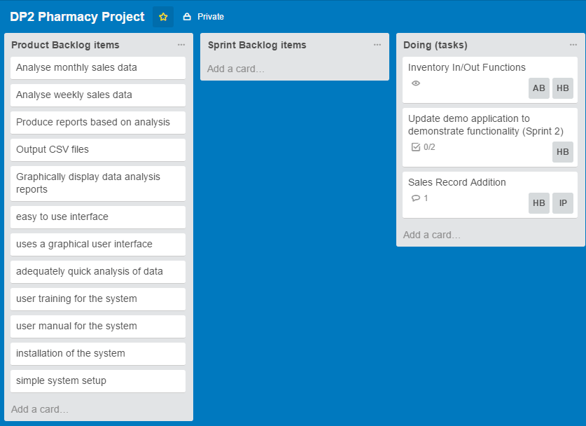

## 22nd Apr

Missed meeting – IP and AB unable to due to personal constraints

## 25th Apr

Meeting Minutes as of 25 Feb

Duration: 10 minutes

Time: 9:30am

Location: Skype Call

Atendees: AB, HB

Summary

Discussed what happened over the last 2 week days.

Demo functionality

Decisions

- AB and HB talked about functionality of demo, what works and what does not.

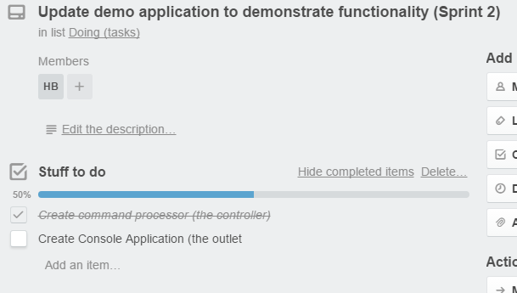

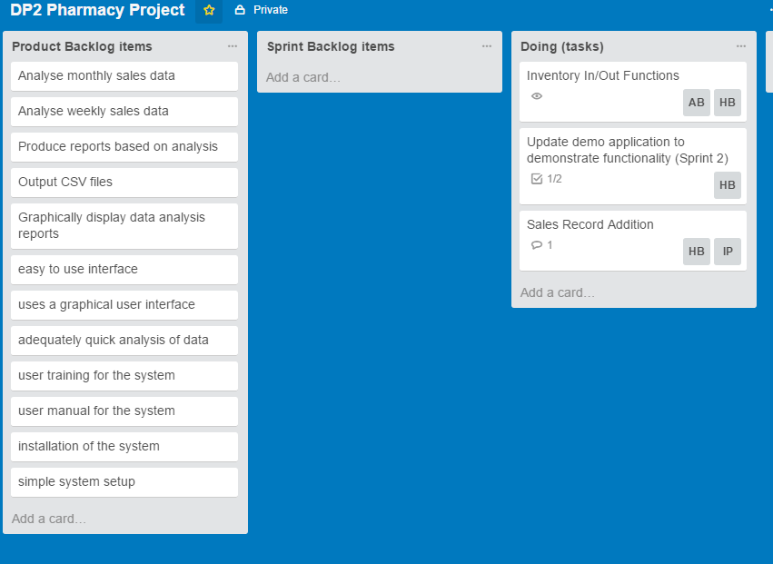

## 26th Apr

Meeting Minutes as of 26 Feb

Duration: 1 hour

Time: 9:30am

Location: Skype Call

Attendees: IP, AB, HB

Summary

Discussed progress made on report. HB contributed a large amount to the sales functions.

Decisions

- IP and AB to read and understand HB's code as they do not understand it very well

- HB managed to accomplish a large amount of work, to continue.

Actions

- APR 27th - IP and AB to contribute

- APR 27th - HB to document code



## 27th Apr

Meeting Minutes as of 27 Feb

Duration: 20 minutes

Time: 9:30am

Location: Skype Call

Attendees: IP, AB, HB

Summary

Talked about what ‘direction’ the program is moving to – what we are implementing and why we are doing it in the way we are.

Also went through HB’s documentation

Decisions

* Code is considerably easier to understand, IP and AB to work through additions

Actions

* APR 28th - HB to add additional functionality
* APR 28th – IP and AB to contribute to currently implemented applications – attempt to reduce error account to manageable levels and reduce lines of code

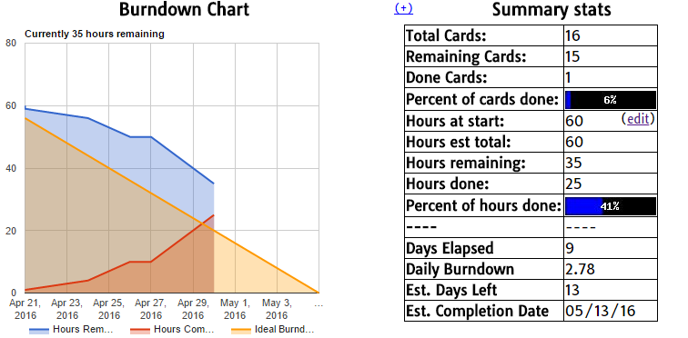

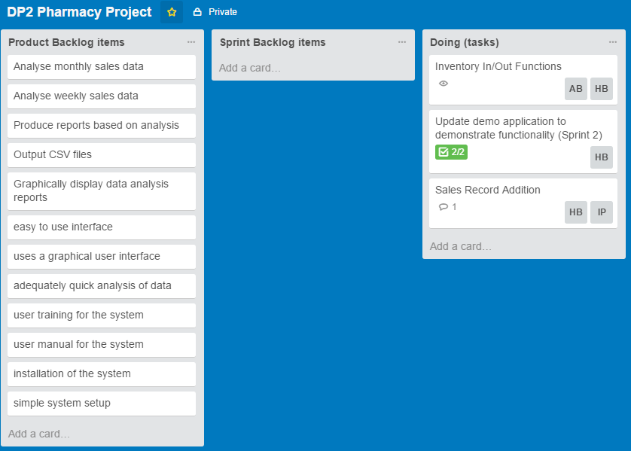

## Repository Changes as of End of Week 1 – Sprint 2

### Commit Statistics

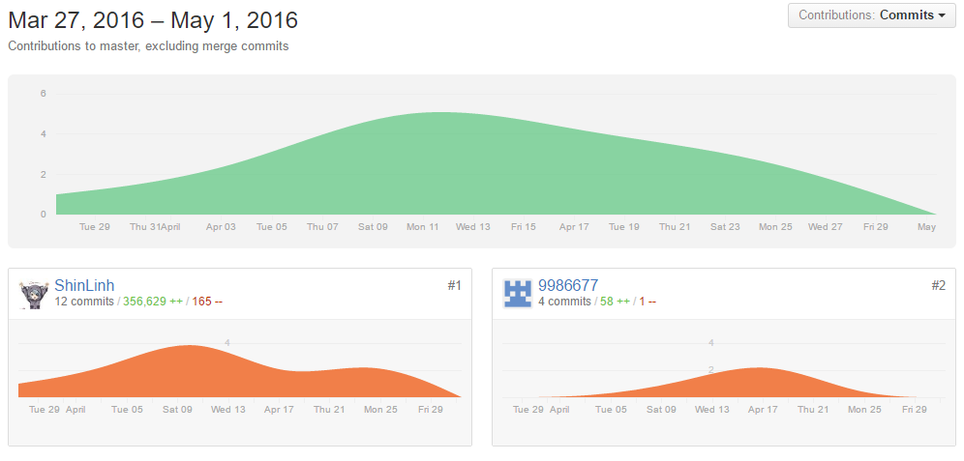

### Repository Root Directory

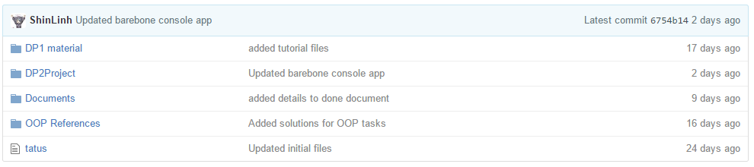

### File Change Statistics

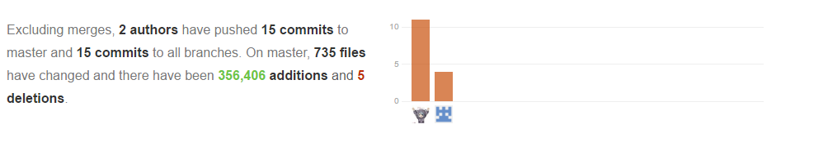

### Discussion

Based off the above graphs we can easily see that our star contributor in this project is Hoang who has contributed approximately half the work for the whole project.

As a group, we have also done a considerable amount of commits with 15 in just this week, more-so than the expected 5 to 10. In comparison to the issues we had in our first sprint we have been proceeding at a very good pace, with expected growth for the next week, the final week of Sprint 2.